Modelling with Power BI Assignment

- What is Power Pivot components and what are its tasks.
Power Pivot is a data modeling tool available in Excel and closely related to Power BI's data engine. It allows you to perform advanced data analysis and create complex data models with large volumes of data.

Component | Task Description
Data Model | Stores data tables, relationships, and metadata. Acts as the central storage and calculation engine.
Data View | Shows tables in a grid format, similar to Excel sheets. Used for editing and viewing data.
Diagram View | Allows visual creation and management of relationships between tables.
DAX (Data Analysis Expressions) | A formula language for creating calculated columns, measures, and KPIs.
Relationships | Connects tables through keys (usually primary to foreign keys). Enables multi-table analysis.
Calculated Columns | New data columns created using DAX formulas.
Measures | Aggregated values used in reports, also created using DAX.
KPIs (Key Performance Indicators) | Visual indicators showing performance progress based on goals.

- What are the different views in Power BI desktop . Explain each which its working.

1. Report View

Purpose: To create and design interactive reports and dashboards using visualizations.

Features:
- Drag and drop fields onto the canvas.
- Use charts like bar, pie, line, cards, tables, maps, etc.
- Apply filters, slicers, and drill-through features.

Working:
- You build reports by selecting visuals and assigning data fields.
- Ideal for presentation and storytelling using the underlying data.

2. Data View

Purpose: To view and inspect the actual data that’s loaded into the model.

Features:
- Shows tables, calculated columns, and data values.
- Allows creation of calculated columns using DAX.
- Data appears in a grid format (like Excel).

Working:
- You can verify, sort, and filter the loaded data.
- It helps in data validation and writing row-level DAX logic.

3. Model View

Purpose: To manage and visualize relationships between different tables.

Features:
- Shows all tables as blocks with their columns.
- Drag-and-drop interface to create or modify relationships.
- Set cardinality (one-to-one, one-to-many, etc.) and filter direction.

Working:
- Critical for building a relational data model (star schema, snowflake, etc.).
- Ensures tables are properly linked for accurate reporting.
3.What are star and snowflake schema with diagrammatical explanation.
1. Star Schema
Definition:
A Star Schema is a denormalized structure where a central Fact Table is connected directly to multiple Dimension Tables.
Characteristics:
- Fact table in the center, dimension tables around it.
- Simpler and faster to query.
- Fewer joins = better performance.
- Used in Power BI, Power Pivot, and data warehouses for reporting.

2. Snowflake Schema

Definition:
A Snowflake Schema is a normalized structure where dimension tables are split into sub-dimensions.

Characteristics:
- Dimension tables are normalized into related tables.
- More joins = slower performance, but reduces data redundancy.
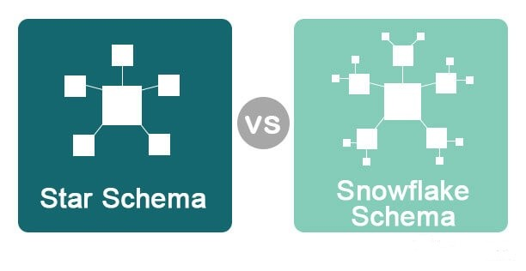
- More complex than star schema.
- What is dimension and fact table.

  - What is dimension and fact table.

Fact Table

Definition: A Fact Table contains measurable, quantitative data about business processes.

Characteristics:
- Stores numeric metrics or facts (e.g., Sales, Profit, Quantity).
- Contains foreign keys that reference dimension tables.
- Often grows quickly in size (many rows).
- Used for calculations, aggregations, KPIs.

Examples of Facts:
- Sales Amount
- Order Quantity
- Profit Margin
- Revenue
DateKey | ProductID | CustomerID | StoreID | SalesAmount | Quantity
20240101 | 101 | 501 | 301 | 5000 | 20

Dimension Table

✔ Definition:
A Dimension Table contains descriptive attributes (text or categorical information) about the data in fact tables.

✔ Characteristics:
- Provides context to facts (who, what, when, where).
- Used for filtering, grouping, and labeling in reports.
- Usually smaller in size.
- Has a primary key that relates to the fact table’s foreign key.

✔ Examples of Dimensions:
- Customer Name
- Product Category
- Region
ProductID | ProductName | Category | Brand
101 | Laptop | Electronics | Dell
- Date

Feature | Fact Table | Dimension Table
Data Type | Numeric, measurable values | Descriptive, categorical information
Purpose | Analysis and aggregation | Filtering, grouping, and labeling
Contains | Foreign keys, facts | Primary keys, descriptions
Size | Large (many rows) | Smaller
Example Columns | SalesAmount, Quantity, Profit | ProductName, Category, CustomerName

